
Semester | T.E. Semester VI– SPCC
Subject | SPCC
Subject Professor In-charge | Prof. Pankaj Vanvari
Assisting Teachers | Prof. Pankaj Vanvari
Laboratory | M310B

Student Name | Pranav Redij
Roll Number | 21102A0003
TE Division | A

Title:
Operator Precedence Parser
Approach:

- Tokenization: The function starts by extracting tokens from the input and storing them in a vector of vectors called Tokensed. Each token is represented as a pair containing its type and value.
- Operator Precedence Table (OPT): The function defines an operator precedence table as a map of pairs of tokens to their precedence relationship (<, >, or =).
- Grammar Definition: Your grammar rules are defined as a vector of vector of vectors named grammar. Each production rule consists of a left-hand side non-terminal followed by its corresponding right-hand side symbols.
- Parsing Loop: The function iterates over the input tokens and uses a stack to perform the parsing. It compares the precedence of the top of the stack with the incoming token based on the operator precedence table.
- Parsing Actions:
  - If the top of the stack has lower precedence than the incoming token (< in OPT), the incoming token is pushed onto the stack.
  - If the top of the stack has higher precedence than the incoming token (> in OPT), it reduces the stack contents based on the grammar rules until the precedence condition is met.
  - If the top of the stack and the incoming token have equal precedence (= in OPT), it pops the stack.
- Grammar Validation: After each reduction step, the function validates whether the reduced symbols form a valid production according to the grammar rules.
- Parsing Completion: Once the entire input has been processed, the function checks if the remaining stack contains only the start symbol and the end-of-file marker. If so, it indicates successful parsing; otherwise, it indicates a syntax error.
- Special Case Handling: There's a special case handling at the end of parsing to handle cases where the last symbol on the stack is E and the incoming token is $, ensuring correct parsing completion.
- Output: The function provides verbose output during the parsing process, including the current stack contents, remaining input, and production reductions.
- Return Value: The function returns true if the input string follows the grammar and false otherwise.

Implementation:
#include <iostream>
#include <fstream>
#include <vector>
#include <string>
#include <map>
#include <stack>
using namespace std;

int readfile(string &fileName, vector<string> &input)
{
char ch;
fstream fp;
fp.open(fileName.c_str(), std::fstream::in);

if (!fp)
{
cerr << "Error opening the file: " << fileName << endl;
return 1; // Return an error code
}

string word;
while (fp >> noskipws >> ch)
{
if (ch == '\n')
{
input.push_back(word);
input.push_back(";");
word = "";
}
else if (ch == ' ')
{
input.push_back(word);
word = "";
}
else
{
word += ch;
}
}

input.push_back(word);

fp.close();
return 0; // Return success code
}

void print_vector_2D(vector<vector<string>> &input)
{
for (int i = 0; i < input.size(); i++)
{
cout << input[i][0] << " "
<< "*->" << input[i][1] << " ";
cout << endl;
}
cout << endl;
}

void print_vector(vector<string> &input)
{
for (int i = 0; i < input.size(); i++)
{
cout << input[i] << " ";
}
cout << endl;
}

void Tokenization(vector<string> &input, vector<vector<string>> &Tokensed, map<string, string> &keywords, map<string, int> &intcp, map<string, float> &floatcp, map<string, string> &idp)
{
int idc = 0;
int intcc = 0;
int floatcc = 0;

for (int i = 0; i < input.size(); i++)
{
if (input[i] == ";")
continue;

if (keywords.find(input[i]) != keywords.end())
{

Tokensed.push_back({keywords[input[i]], "NA"});
}
else
{
// if the value in not in keyword db it can be eithre identifier or constant

string curr = input[i];
char first_of_curr = curr[0]; // foc
int val_of_foc = first_of_curr - '0';
// cout << val_of_foc << endl;
if (val_of_foc >= 0 && val_of_foc <= 9)
{
bool isfloat = false;
for (auto x : curr)
{
if (x == '.')
isfloat = true;
}
if (isfloat)
{
float v = atof(curr.c_str());
string p = to_string(floatcc);
Tokensed.push_back({"3", p});
floatcp[p] = v;
floatcc++;
}
else
{
int v = stoi(curr);
string p = to_string(intcc);
Tokensed.push_back({"2", p});
intcp[p] = v;
intcc++;
}
}
else
{
string p = to_string(idc);

Tokensed.push_back({"1", p});
idp[p] = curr;
idc++;
}
}
}
}

void print_all_Symtabs(map<string, int> &intcp, map<string, float> &floatcp, map<string, string> &idp)
{
cout << "The integer constant pointer is: " << endl;
for (auto x : intcp)
{
cout << x.first << "->" << x.second << endl;
}
cout << endl;

cout << "The float constant pointer is: " << endl;
for (auto x : floatcp)
{
cout << x.first << "->" << x.second << endl;
}
cout << endl;

cout << "The identifier pointer is: " << endl;
for (auto x : idp)
{
cout << x.first << "->" << x.second << endl;
}
cout << endl;
}

void DisplayPT(vector<vector<string>> productions, map<vector<string>, int> PT)
{
cout << "table" << endl;
;
}

void Print_1D_vector(vector<string> v)
{
int n = v.size();
for (int i = 0; i < n; i++)
{
cout << v[i] << " ";
}
cout << endl;
}
//--------------------------------------------------------------------------------------------------

void fillTokens(vector<string> &Tokens, vector<vector<string>> Tokensed)
{
int n = Tokensed.size();
for (int i = 0; i < n; i++)
{
Tokens.push_back(Tokensed[i][0]);
}
}
bool OPP(vector<vector<string>> Tokensed)
{
vector<string> Tokens;
fillTokens(Tokens, Tokensed);
cout << "The tokens that we have are:" << endl;
Print_1D_vector(Tokens);

// Operator precidecnce table
map<vector<string>, string> OPT;
OPT[{"4", "4"}] = ">";
OPT[{"4", "5"}] = ">";
OPT[{"4", "6"}] = "<";
OPT[{"4", "7"}] = "<";
OPT[{"4", "8"}] = "<";
OPT[{"4", "1"}] = "<";
OPT[{"4", "10"}] = "<";
OPT[{"4", "11"}] = ">";
OPT[{"4", "$"}] = "<";
OPT[{"4", "2"}] = "<";

OPT[{"5", "4"}] = ">";
OPT[{"5", "5"}] = ">";
OPT[{"5", "6"}] = "<";
OPT[{"5", "7"}] = "<";
OPT[{"5", "8"}] = "<";
OPT[{"5", "1"}] = "<";
OPT[{"5", "10"}] = "<";
OPT[{"5", "11"}] = ">";
OPT[{"5", "$"}] = ">";

OPT[{"6", "4"}] = ">";
OPT[{"6", "5"}] = ">";
OPT[{"6", "6"}] = ">";
OPT[{"6", "7"}] = ">";
OPT[{"6", "8"}] = "<";
OPT[{"6", "1"}] = ">";
OPT[{"6", "10"}] = "<";
OPT[{"6", "11"}] = ">";
OPT[{"6", "$"}] = ">";

OPT[{"7", "4"}] = ">";
OPT[{"7", "5"}] = "<";
OPT[{"7", "6"}] = ">";
OPT[{"7", "7"}] = ">";
OPT[{"7", "8"}] = "<";
OPT[{"7", "1"}] = ">";
OPT[{"7", "10"}] = "<";
OPT[{"7", "11"}] = ">";
OPT[{"7", "$"}] = ">";

OPT[{"8", "4"}] = ">";
OPT[{"8", "5"}] = ">";
OPT[{"8", "6"}] = ">";
OPT[{"8", "7"}] = ">";
OPT[{"8", "8"}] = ">";
OPT[{"8", "1"}] = ">";
OPT[{"8", "10"}] = "<";
OPT[{"8", "11"}] = ">";
OPT[{"8", "$"}] = ">";

OPT[{"1", "4"}] = ">";
OPT[{"1", "5"}] = "<";
OPT[{"1", "6"}] = ">";
OPT[{"1", "7"}] = ">";
OPT[{"1", "8"}] = ">";
OPT[{"1", "1"}] = ">";
OPT[{"1", "10"}] = "<";
OPT[{"1", "11"}] = ">";
OPT[{"1", "$"}] = ">";
OPT[{"1", "9"}] = "<";

OPT[{"10", "4"}] = "<";
OPT[{"10", "5"}] = "<";
OPT[{"10", "6"}] = "<";
OPT[{"10", "7"}] = "<";
OPT[{"10", "8"}] = "<";
OPT[{"10", "1"}] = "<";
OPT[{"10", "10"}] = "<";
OPT[{"10", "11"}] = "=";
OPT[{"10", "$"}] = "";

OPT[{"11", "4"}] = ">";
OPT[{"11", "5"}] = ">";
OPT[{"11", "6"}] = ">";
OPT[{"11", "7"}] = ">";
OPT[{"11", "8"}] = ">";
OPT[{"11", "11"}] = ">";
OPT[{"11", "$"}] = ">";

OPT[{"$", "4"}] = "<";
OPT[{"$", "5"}] = "<";
OPT[{"$", "6"}] = "<";
OPT[{"$", "7"}] = "<";
OPT[{"$", "8"}] = "<";
OPT[{"$", "1"}] = "<";
OPT[{"$", "$"}] = "<";

OPT[{"3", "4"}] = ">";
OPT[{"3", "5"}] = "<";
OPT[{"3", "6"}] = ">";
OPT[{"3", "7"}] = ">";
OPT[{"3", "8"}] = ">";
OPT[{"3", "3"}] = ">";
OPT[{"3", "10"}] = "<";
OPT[{"3", "11"}] = ">";
OPT[{"3", "$"}] = ">";

OPT[{"2", "4"}] = ">";
OPT[{"2", "5"}] = "<";
OPT[{"2", "6"}] = ">";
OPT[{"2", "7"}] = ">";
OPT[{"2", "8"}] = ">";
OPT[{"2", "2"}] = ">";
OPT[{"2", "10"}] = "<";
OPT[{"2", "11"}] = ">";
OPT[{"2", "$"}] = ">";

OPT[{"9", "2"}] = "<";
OPT[{"9", "3"}] = "<";
OPT[{"9", "1"}] = "<";
OPT[{"9", "10"}] = "<";
OPT[{"9", "11"}] = ">";
OPT[{"9", "$"}] = ">";

// Defining the grammar
vector<vector<vector<string>>> grammar;
grammar.push_back({{"E"}, {"E", "4", "E"}});
grammar.push_back({{"E"}, {"E", "5", "E"}});
grammar.push_back({{"E"}, {"E", "6", "E"}});
grammar.push_back({{"E"}, {"E", "7", "E"}});
grammar.push_back({{"E"}, {"E", "8", "E"}});
grammar.push_back({{"E"}, {"1"}});
grammar.push_back({{"E"}, {"10", "E", "11"}});
grammar.push_back({{"E"}, {"2"}});
grammar.push_back({{"E"}, {"3"}});
grammar.push_back({{"S"}, {"1", "9", "E"}});

// stack with $ as the bottom element
stack<string> st;
st.push("$");

int n = Tokens.size();

for (int i = 0; i < n; i++)
{
string incoming = Tokens[i];
// current content of stack
stack<string> temp = st;
stack<string> temp2;
while (!temp.empty())
{
temp2.push(temp.top());
temp.pop();
}

// displaying the current stack

cout << "The current stack is:" << endl;
while (!temp2.empty())
{
cout << temp2.top() << " ";
temp2.pop();
}
cout << endl;

// reamining input
cout << "The remaining input is:" << endl;
for (int j = i; j < n; j++)
{
cout << Tokens[j] << " ";
}
cout << endl;

cout << "----------------------------" << endl;

while (1)
{
string top = st.top();
// the baic condtion of success
if(top=="10"){
return false;
}

// condtion when stack top is E and incoming is $
if (top == "E" && incoming == "$")
{
st.pop();
string newtop = st.top();
st.push("E");
top = newtop;

cout << "The stack top is E and incoming is $" << endl;
temp = st;
while (!temp.empty())
{
temp2.push(temp.top());
temp.pop();
}

cout << "The current stack is:" << endl;
while (!temp2.empty())
{
cout << temp2.top() << " ";
temp2.pop();
}
cout << endl;
}

if (top == "S" && incoming == "$")
{
return true;
}

// if the top is less than incoming
if (OPT[{top, incoming}] == "<")
{
st.push(incoming);
break;
}

// if the top is greater than incoming
if (OPT[{top, incoming}] == ">")
{
vector<string> temp;
while (1)
{
string top = st.top();
st.pop();
temp.push_back(top);
if (OPT[{st.top(), top}] == "<")
{
break;
}
}

temp.reserve(temp.size());

// checking if the temp is a valid production
int m = grammar.size();
bool found = false;
for (int j = 0; j < m; j++)
{
if (grammar[j][1] == temp)
{
found = true;
st.push(grammar[j][0][0]);
cout<<st.top()<<endl;
break;
}
}

cout << "The production to find:" << endl;
for (int i = 0; i < temp.size(); i++)
{
cout << temp[i] << " ";
}
cout << endl;

if (!found)
{
cout << "The production is not valid" << endl;
return false;
}
if(incoming!="$")
st.push(incoming);

if(incoming=="$")
i--;
break;
}

// if not in precedence table
if (OPT.find({top, incoming}) == OPT.end())
{
return false;
}
}
}

if(st.top()=="$")
st.pop();

while(1){

string special="";
string incoming = "$";
string top = st.top();
// current content of stack
stack<string> temp = st;
stack<string> temp2;
while (!temp.empty())
{
temp2.push(temp.top());
temp.pop();
}

// displaying the current stack

cout << "The current stack is:" << endl;
while (!temp2.empty())
{
cout << temp2.top() << " ";
temp2.pop();
}
cout << endl;

if (top == "E" && incoming == "$")
{
st.pop();
string newtop = st.top();
st.push("E");
top = newtop;

cout << "The stack top is E and incoming is $" << endl;
temp = st;
while (!temp.empty())
{
temp2.push(temp.top());
temp.pop();
}

cout << "The current stack is:" << endl;
while (!temp2.empty())
{
cout << temp2.top() << " ";

special=special+temp2.top();
temp2.pop();
}

cout << endl;
//cout<<"special:"<<special<<endl;
}

if(special=="$19E"){
st.pop();
st.pop();
st.pop();

st.push("S");

continue;
}

if (top == "S" && incoming == "$")
{
return true;
}

// if the top is less than incoming
if (OPT[{top, incoming}] == ">")
{
// st.push(incoming);
break;
}

// if the top is greater than incoming
if (OPT[{top, incoming}] == "<")
{
vector<string> temp;
while (1)
{
string top = st.top();
st.pop();
temp.push_back(top);
if (st.top()=="9"||OPT[{st.top(), top}] == "<")
{
break;
}
}

temp.reserve(temp.size());

// checking if the temp is a valid production
int m = grammar.size();
bool found = false;
for (int j = 0; j < m; j++)
{
if (grammar[j][1] == temp)
{
found = true;
st.push(grammar[j][0][0]);
cout<<st.top()<<endl;
break;
}
}

cout << "The production to find:" << endl;
for (int i = 0; i < temp.size(); i++)
{
cout << temp[i] << " ";
}
cout << endl;

if (!found)
{
cout << "The production is not valid" << endl;
return false;
}

}

// if not in precedence table
if (OPT.find({top, incoming}) == OPT.end())
{
return false;
}
}

cout<<"hi"<<endl;
return false;
}

//---------------------------------------------------------------------------------------------------
int main()
{
// Database starts
map<string, string> keywords;
keywords["int"] = "INT";
keywords["float"] = "FLOAT";
keywords["+"] = "4";
keywords["-"] = "5";
keywords["*"] = "6";
keywords["/"] = "7";
keywords["="] = "9";
keywords["^"] = "8";
keywords["("] = "10";
keywords[")"] = "11";
keywords["$"] = "$"; // End of file
// 3 for float
// 2 for int

// 1 for identifiers

// pointer to intc
map<string, int> intcp;
// pointer ot intf
map<string, float> floatcp;
// pointer to identifier
map<string, string> idp;

// Database ends
string inputFile;
vector<string> input;
vector<vector<string>> Tokensed;

cout << "Enter the name of the file: ";
cin >> inputFile;
readfile(inputFile, input);

cout << "The input file is: " << endl;
print_vector(input);

Tokenization(input, Tokensed, keywords, intcp, floatcp, idp);
cout << "The tokens are: " << endl;
print_vector_2D(Tokensed);

print_all_Symtabs(intcp, floatcp, idp);

// Logic of Parser

bool Parsed = OPP(Tokensed);

if (Parsed)
{
cout << "The string follows the grammer" << endl;
}
else
{
cout << "The grammer is not followed" << endl;
}

return 0;
}

End Result:

Accepted=>
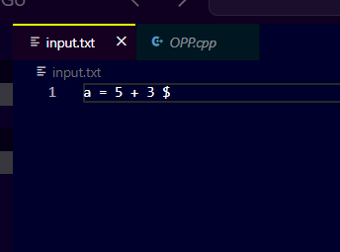

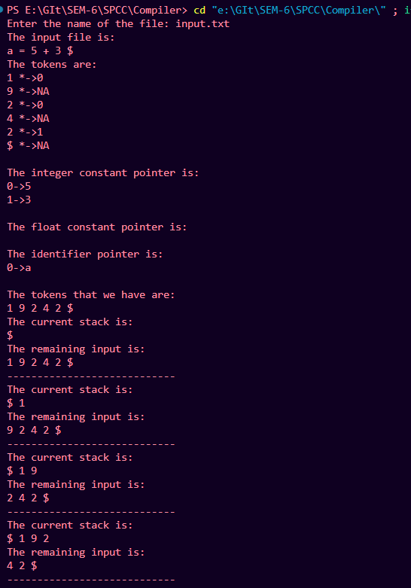

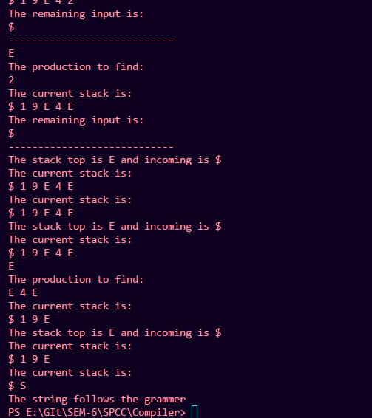

Not Accepted=>

